A Multilingual Virtual Classroom Network for a Software Engineering Course

Katerina Zdravkova ⁽¹⁾
Klaus Bothe ⁽²⁾
Zoran Budimac ⁽³⁾

⁽¹⁾ Institute of Informatics, University “Sts Cyril and Methodius” – Skopje, Macedonia
⁽²⁾ Institute of Informatics, Humboldt University – Berlin, Germany
⁽³⁾ Institute of Mathematics and Informatics, University of Novi Sad – Novi Sad, Yugoslavia
e-mails: keti@ii.edu.mk; bothe@informatik.hu-berlin.de; zjb@im.ns.ac.yu

Abstract
The intention of the Multilingual Virtual Classroom Network is to enable the usage of a shared virtual classroom for software engineering lectures in ten schools and four countries. It is intended to consist of a Center Point at the Humboldt University in Berlin and four National Centers in Germany, Yugoslavia, Macedonia and Bulgaria. This paper presents the virtual classroom architecture, as well as the structure and the contents of the main site and of the national mirror sites.

1. Setting up the scene

In 2001, a DAAD project “Software Engineering Education and Reverse Engineering” was launched. Initially, it involved four schools in four countries. At this moment, ten schools from six universities collaborate on several tasks. The most important are:
- Introduction of software engineering course in South East Europe,
- Creation of a joint course on software engineering,
- Preparation and implementation of learning and teaching materials,
- Realization of representative case studies,
- Dissemination of project results, and
- Preparation of prerequisites for project maintenance and upgrading.

1.1. Software engineering course

The first project workshop was held in October 2001 in Novi Sad, Yugoslavia. In order to prepare a basis for a joint software engineering course, its syllabi, computing curricula and the infrastructure at all South-East European schools were discussed. Surprisingly, software engineering was a regular course in two schools, and to some extent, in other two schools. Most computing curricula were completely outdated and the infrastructure in all Yugoslav schools was poor.

The workshop was a catalyst for immediate changes. As a consequence, one school has already restructured and two are in the process of restructuring computing curriculum. Software engineering course has become, or it is intended to become, a core course at undergraduate or postgraduate studies in most of the schools involved in the project.

1.2. Joint course on software engineering

One of the most important issues of DAAD project is the creation of a joint course on software engineering. The motivation for a joint course in several schools was:
- Knowledge dissemination and transfer
- Reduction of expenses (reuse of slides, assignments, case studies, ...and others)
- Transfer of credits
- Joint discussion forums (on contents, didactics, literature, assignments, ...and others).
Software engineering course has a long tradition at the Humboldt University in Berlin. After five years of extensive work, the course is becoming stable. Its syllabus is being developed in accordance to CC2001 [4]. With 60 lecture hours, 30 lecture hours for practical exercises and 30 lecture hours for assignments (i.e. 60 + 30 +30 lecture hours), it covers the most of recommended core topics, as well as many elective topics. It also gives good theoretical basis for future research and development. The course is enriched with many case studies based on life problems [1
  - ]. They give the opportunity to exploit all software engineering elements, including teamwork and software system management. Finally, it presents many practical aspects of software engineering.

1.3. Learning and teaching materials

Teaching materials appear both as text files and as Power Point presentations (Fig. 1.). They are prepared for the purposes of the software engineering course at Humboldt University, and therefore they are in German. Every slide has got short notes with useful hints for the potential lecturers that will use them. All teaching materials are regularly updated to be in line with the modern trends in software engineering education. Upgrades are done at the Humboldt University with some involvement of other project participants.

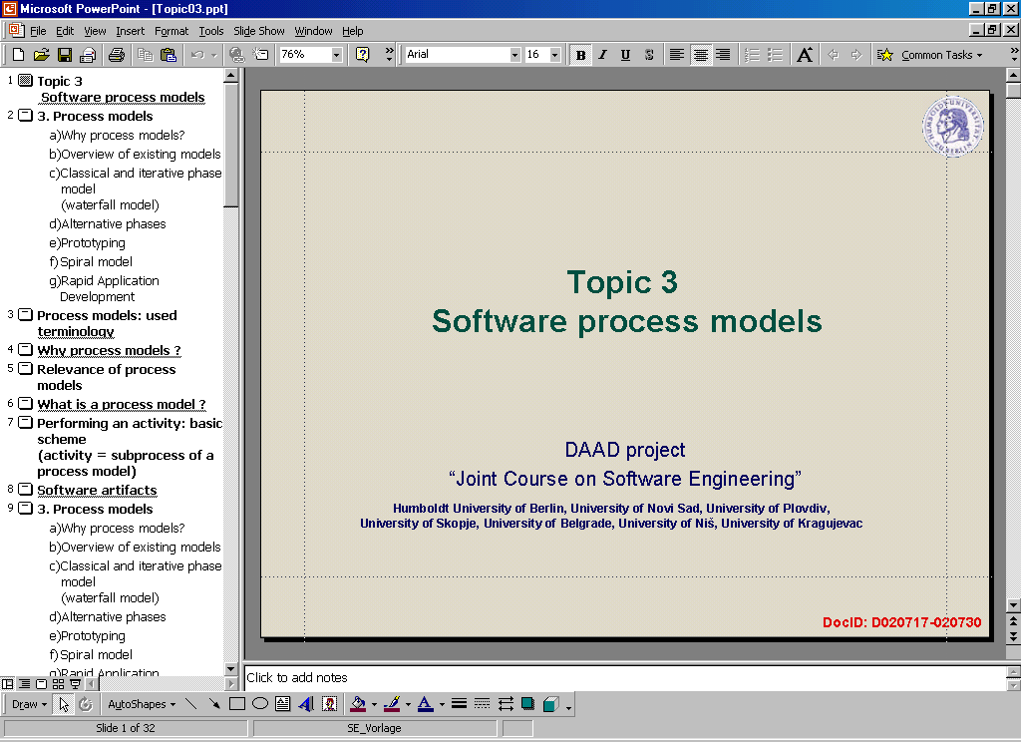

Figure 1. Typical look of the Power Point lecture slides

Since many project participants are not familiar with the German language, English was chosen to be an intermediate language. Translation process of the presentations into English has already started and the current stage was reported during the second project workshop held in Plovdiv, Bulgaria in September 2002. Reproduction of lecture notes according to these presentations was more than successful. It encourages keeping to this direction.

1.4. Dissemination

The first activity towards dissemination of project results was its Web presentation (Fig. 2.). It can be accessed at http://www.informatik.hu-berlin.de/swt/intkoop/se/index.htm. Parts of the site are still under construction, particularly those concerning supporting slides and literature for lecturers, case studies and student assignments.

Both past workshops and the forthcoming one in Ohrid, Macedonia, unite many lecturers and students from different countries. Their number is increasing and involves members from schools that are not active project partners. They share the experience obtained during these international meetings and initiate improvements with the colleagues at their own schools. Finally, the dissemination is enabled through the reports and the papers that are a result of the project.

2. The structure of the software engineering course Sites

In February 2002, a software engineering course site was created at the Humboldt University in Berlin (Fig. 2.). It gives an overview of all activities concerning the project and detailed information concerning the software engineering course.

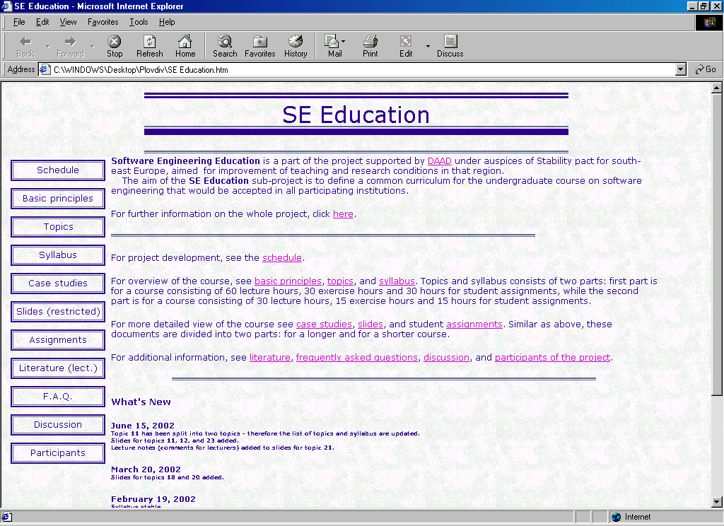

Figure 2. Software engineering education homepage

The links related to the project point to: the schedule of project development, and the participants of the project. The first link is the best indicator of the project’s progress. Currently, the project is divided into fourteen tasks. By now, a half of them have started. Therefore, only their links point to some contents. Activities corresponding to the last group of links have not started yet, but they are expected to start soon and be completed before the last project workshop. They will present the allowed differences between individual syllabi, adjusting criteria for exams and exercises, and the joint textbook These tasks need more intensive collaboration between the Berlin school and those South East European schools that have already started, or intend to start software engineering course soon. Once the differences between individual syllabi and the criteria for the assignments and examinations are adjusted, credit transfer will be possible.

At the beginning, the credit transfer between the Humboldt University in Berlin and other South East European schools is a priority. With time, mutual transfer will also be established.

The following links, which are divided into three groups, are more important for the software engineering training and teaching:
- Overview of the course: basic principles, topics and syllabus,
- Elements of the course: case studies, slides, common student assignments, and

- Software engineering: literature, F.A.Q. and Discussion forum.

Each group is in fact a smaller task within the whole project. The first group of tasks has already been completed. The course at the Humboldt University Berlin has 60 + 30 + 30 lecture hours. This portion of the course is not appropriate for all participating schools in the project. For this reason the site offers two potential syllabi: a full syllabus, and a syllabus for a short course with 30 + 15 + 15 lecture hours. Presentation of the syllabi appears in two versions: short and detailed one. The detailed syllabus is a good indicator of the compatibility of suggested syllabi with the one in CC2001.

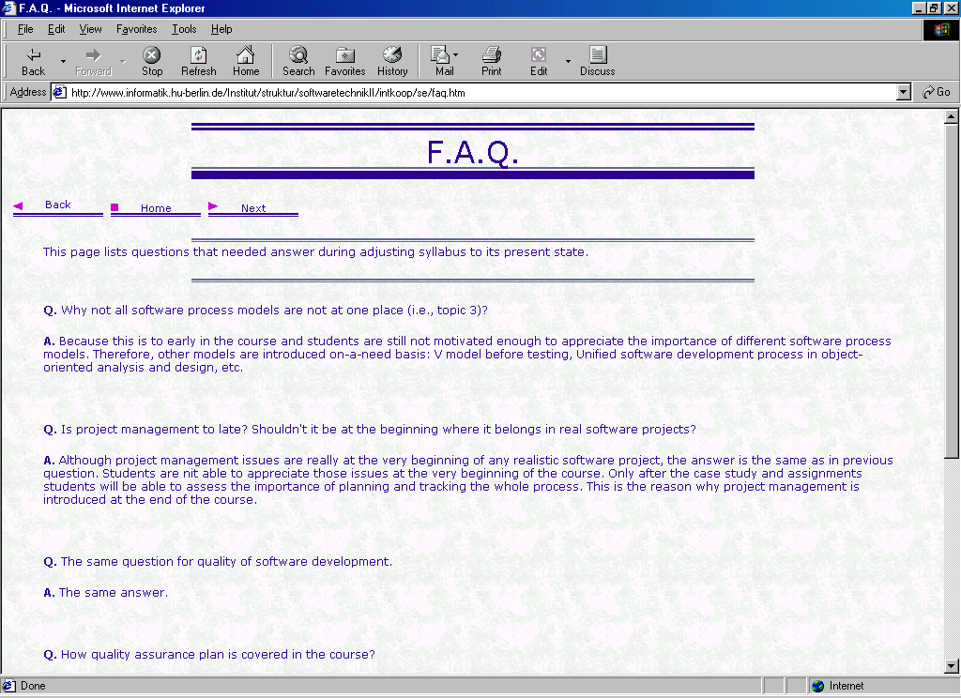

Figure 3. An example of the F.A.Q. at the Center Point

All three links from the second group are password protected. The contents in English have not been completed yet. However, about 50% of it has already been finished. In the last group of tasks, only the final one is under construction, mainly because of its dynamic structure and compatibility reasons in the virtual classroom Network.

The third group of links is at the beginning of its development. As a result of several conversations, the part dealing with the frequently asked questions (Fig. 3.) has few contents. There will be more contents after the installation of the Discussion forum, because F.A.Q. are intended to consist of the most relevant topics discussed.

3. Structure of the network

In software engineering education, there are examples of cooperative work across universities [2]. Furthermore, the Web provides presentation and delivery of multimedia contents. As a consequence, traditional classrooms are being replaced by virtual classrooms every day [3]. They enable on-line learning and bring together many students no matter the place and time.

There was a strong motivation to create an international network of virtual classrooms. At first, encouragement was the collaboration established during the project. Second, the experience in software engineering education at Berlin school was found very valuable for all current and potential lecturers. Third, prepared materials are approved and Web transferable. Finally, important is (at least) acceptable hardware and software infrastructure, and the experience in distance learning, particularly in Skopje, Macedonia (http://www.odoserver.pmf.ukim.edu.mk).

The network is free for all lecturers and students at the participating schools in the project. Parts of the contents of these Web-based virtual classrooms are password protected.

The network is supposed to consist of a Center Point in Berlin and four National Centers in Germany, Yugoslavia, Macedonia and Bulgaria. The Center acts as a heart of the whole system. Its main goal is to present the syllabus for the software engineering course, the lecture notes in Power Point, and information about the past, current and future activities concerning the project. Furthermore, it contains a particular site with links to its National Centers. In addition, the Center Point contains links to the most relevant sites dealing with the software engineering, with its education and with the important meetings related to the topic.

To conclude, the Center Point:
- Sends information to the National Centers, supervises and co-ordinates their work,

- Receives new lecture notes from all partner institutions,
- Enables
- centralized communication between National Centers, and

- Updates and fills in new information.

Most of the links at the Center Point are links coming directly from the existing software engineering education site (Fig. 2.). The links that are relevant for the virtual classroom are: the overview of the course, the elements of the course, the software engineering links, and the Discussion Forum. Additionally, the virtual classroom is intended to contain several other links as follows:
- Bi-directional communication Center Point ↔ National Center,
- User and mailing list,
- Site traffic indicator,
- Links to national pages,
- News,
- Important meetings and others.

The Center Point is connected with four national sites, called National Centers. Basically, National Centers are mirror sites (Fig. 4.), but at the same time they are independent units of the whole network. Mirror site at the Humboldt University Berlin is physically virtual mirror site. At the National Centers, independent are the syllabus, the selection of the materials relevant for the course, the assignments, the place, the time, the list of lecturers and students, and some other elements concerning the national course. Additionally, National Centers have the possibility to insert individual links. For example, some of the national sites might have e-chat facilities on a local level. The Macedonian site will indoubtedly include self-testing and e-testing modules.

At the center site, all materials are presented in English. The contents at the mirror sites are coupled with translated materials presented in the official language of the country. Mirror of the English contents was discussed during the second project workshop. The main objectives of its presence are to help relieve the Berlin server of some of the traffic, and the need of a local access to all materials related to the network. Furthermore, it facilitates translation, because the framework remains unchanged. The only difference between different language presentations is in fact their textual database.

The Center Point is mainly static, since the contents can be filled in and changed locally. At the moment, only the Discussion Forum is dynamic. Mirror of this link is still discussed, because its on-line modifications are a serious problem. If the problem with the dynamic on-line mirror of the Discussion forum is solved, then it will also be a part of the mirror site. Otherwise, discussions concerning the project will be performed only in Berlin.

Course elements
Course overview
Discussion Forum
German mirror site
F.A.Q.
Course elements
Course overview
National Point 5
Course elements
Course overview
Bulgarian mirror site
F.A.Q.
Discussion Forum
Course elements
Course overview
Macedonian mirror
F.A.Q.
Discussion Forum
Course overview
C E N T E R P O I N T
Course elements
F.A.Q.
Discussion Forum
Course elements
Course overview
National Point 2
Course elements
Course overview
National Point 1
Course elements
Course overview
Yugoslav mirror site
F.A.Q.
Discussion Forum

Figure 4. Center Point and National mirror sites

At the National Centers (Fig. 5.), dynamic access and interactivity will be enabled. Dynamic and/or interactive are:
- The National Discussion Forum,
- The user lists,
- The individual assignments and deadlines,
- The solutions of the assignments,
- The list of results,
- The bi-directional lecturer/student communication,
- The national indicator of site traffic and other.

It is worth mentioning that software engineering education site has its copy in Novi Sad, Yugoslavia (http://perun.im.ns.ac.yu/projects.html), which can be treated as a virtual mirror site. At this moment, there are no differences between its contents and the contents in Berlin. Modifications can soon be expected, particularly because of the engagements of this school in the case studies.

The role of the National Center in Novi Sad is specific and more challenging. In fact, this point is a National Center of six National Points:
- Faculty of Sciences in Novi Sad, acting as a National Center,
- Faculty of Electrical Engineering in Belgrade,
- Faculty of Mathematics in Belgrade,
- High Technical School in Novi Sad,
- Faculty of Electronics in Nis, and
- Faculty of Mechanical Engineering in Kragujevac.

With this national network, all Yugoslav universities and almost all schools where there is training in Computing and Computer Science will be covered. The network will enable better communication in the field of software engineering and will be a good starting point for credit transfer in Yugoslavia.

Center Point (English)
Syllabus
Slides
Case studies
Assignments
Static contents
Dynamic contents
Discussion Forum
Mailing list
F.A.Q.
National Point 1
Syllabus 1
Slides 1
Case studies 1
Assignments 1
Selected contents 1
Dynamic contents 1
Local discussions
Local lists
F.A.Q.
National Mirror site
Slides
Syllabus
Case studies
Assignments
Static contents
Dynamic contents
Discussion forum
Mailing list
F.A.Q.
National Center A
Syllabus A
Slides A
Case studies A
Assignments A
National contents A
Dynamic contents A
Discussion forum
User / mail
F.A.Q.
Translated Mirror site
Slides
Syllabus
Case studies
Assignments
Static contents

Figure 5. Communication within the network

The Yugoslav National Center has a role of a by-pass between the Center Point and the National Points. This crossing point is the only site with the right to update the contents of the National site dependently on the changes initiated by the Center Point. Representatives of other five National Points can also initiate modification of the contents at the National Center, but in such case it will have to be validated by the Project Board. The contents approved by the Board will be exposed at the National Center and then passed on to the mirror sites. Such centralization is not very practical, but at the stage when most schools have limited experience in the field, it is the most appropriate.

4. Conclusions and work to be done

The Multilingual Virtual Classroom Network for the software engineering course initiated by the project “Software Engineering Education and Reverse Engineering“ is the first international virtual classroom set in South-East Europe. Supported and supervised by the Humboldt University in Berlin, the network connects three countries and many schools. Its goal is to define a framework for all potential joint courses within participating schools. All that courses will be in line with European standards, thus the project will be a good basic for establishing European Credit Transfer System in South East Europe. Besides the Humboldt University, as a part of the software design course, the University of Novi Sad will start using selected lectures and slides based on our joint project from 1 October 2002.

At this moment, the network of virtual classrooms is at its beginning. Many tasks have already been done, but there is so many to do. A distribution of assignments has been made during the last project workshop. The participants from the Humboldt University Berlin have to prepare remaining Power Point slides first. They will add notes that assist better reproduction of the lectures. Translation, in the beginning only from German into English, in addition to the adaptation and the improvement of the English slides, will be made at the National Centers and at the Faculty of Electrical Engineering in Belgrade. Development of the case studies will also be done at the National Centers, in particular in Plovdiv and in Novi Sad. When lecture notes become stable, translation from English to Bulgarian, Macedonian and Serbian will be made manually in their National Centers.

As far as the Center Point is hosted in Berlin, the basis for future mirror sites must be enabled at the Humboldt University. The static part of the network will mainly be done by the Novi Sad group. The experiments of the national mirror sites will also start here. The dynamic part of the network will be created in Skopje. The first task of this group is the Discussion forum that will be hosted in Berlin. The estimated duration of all these tasks is about one year. It can be done only if most activities are carried out in parallel. Previous experience in this project promises that the deadline will not be broken.

Acknowledgement:

We acknowledge the support of DAAD (German Academic Exchange Service) through which the work reported here is being funded.

References:

[1] K. Bothe: Reverse Engineering: the Challenge of Large-Scale Real-World Educational Projects, CSEET 2001, Charlotte, NC, February 2001.
[2] O. P. Brereton, S. Lees and R. Bedson: Student Collaboration across Universities: A Case Study in Software Engineering, 13th Conference on Software Engineering Education & Training, Austin, 2000.
[3] IIL, International Institute for Learning, Inc: Microsoft Project Virtual Classroom eLearning Courses (http://www.iil.com/microsoft_project_training/microsoft_project_virtual_classroom_courses.asp), 2002
[4] The Joint Task Force on Computing Curricula, Computing Curricula 2001, Computer Science, IEEE Computer Society & Association for Computing Machinery, December 2001.

