Multilingual Virtual Classroom Network
for Software Engineering Module

Klaus Bothe*
Zoran Budimac**
Katerina Zdravkova***
(Version 0.1, 2002-02-12)

*Institute of Informatics, Humboldt University - Berlin
e-mail: Bothe@informatik.hu-berlin.de
**Institute of Mathematics and Informatics, University Novi Sad
e-mail: zjb@im.ns.ac.yu
***Institute of Informatics, Faculty of Sciences, University “Sts Cyril and Methodius”- Skopje
e-mail: Keti@pmf.ukim.edu.mk

Abstract

The intention of Multilingual Virtual Classroom Network (MVCN) is to enable the usage of a common Virtual Classroom for Software Engineering lecture notes at eight schools in four countries. This article presents the framework of MVCN. It is intended to consist of a Centre Point at Humboldt University and four National Centre Points. In order to facilitate mutual communication, intermediate language of MVCN is English, whereas NCPs use the official language of the country.

Keywords:

Introduction: The intention of Multilingual Virtual Classroom Network (MVCN) is to enable establishing of a joint course as well as a common Virtual Classroom for Software Engineering lecture notes at these schools:
- Institute of Informatics, Humboldt University in Berlin, Germany,
- Institute of Mathematics and Informatics, University of Novi Sad, Yugoslavia
- Faculty of Mathematics and Informatics, University of Plovdiv, Bulgaria, and
- Institute of Informatics, University “Sts Cyril and Methodius“ in Skopje, Macedonia

Joint syllabus for Software Engineering module is one of the main outcomes of DAAD project “Reverse Engineering and distributed cooperative software development” that was launched in 2001. The second outcome is creation of common lecture notes for all schools that are involved in the project and are interested to use them in the process of training and teaching. These lecture notes have already been created (Bothe, 2001?) and preparation of Power Point presentations is currently taking place. Translation, interpretation and analysis of the presentations will be the main goal of forthcoming project workshop scheduled for the fall.

The Centre Point of the Virtual Classroom will be located at the Institute of Informatics in Berlin (Fig. 1). It has been chosen for its tradition in Software Engineering module, as well as for its ICT facilities. At the centre site, all materials are presented in English, which has been chosen to be an intermediate language perfect for communication of all involved schools. Centre point is connected with four mirroring national sites, called National Centres. Mirroring site at Humboldt University is physically virtual, with mirroring content in German. All contents at the mirroring sites are presented at the official language of the country.

It’s worth mentioning that at this moment only Novi Sad is the real National Centre for four institutions from remaining four Yugoslav universities:
- Faculty of Electrical Engineering, University of Belgrade
- Faculty of Sciences, University of Belgrade
- Faculty of Sciences and Mathematics, University of Nis
- Faculty of Mechanical Engineering, University of Kragujevac

As far as is the only Yugoslav institution in the project with active participation in creation of SE module and its presentation on Web, it is behaving as a by-pass between Centre point and National Points. This crossing point is the only site with the right to update the content of the site dependently on the changes initiated by the Centre Point. Representatives of other four national sites can also initiate modification of the content, but in such case it will have to be validated by the Board of MVCN, exposed at the Centre Point and then passed on other mirroring sites.

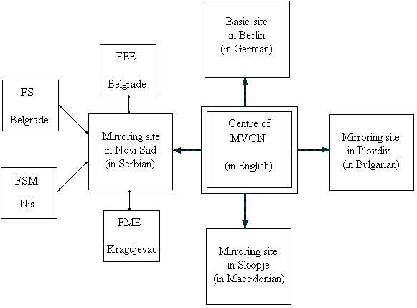
Figure 1. Structure of MVCN

Structure of MVCN: Centre Point acts as a heart of the whole system. It sends information to National Points, supervises and co-ordinates their work. It also receives new lecture notes from all involved partner institutions. In order to reduce translation tasks, all lecture notes are produces in English and then manually translated into four remaining languages. The Centre Point also enables centralized communication between National Points. For that purpose, a common Bulletin Board is set here. Access to visit it is free for all participants, while only Centre Point has the right to update it and fill in new information. Common Bulletin Board does not exclude mutual communication between particular points of the network, which is performed via e-mail. If any information exchanged between several members of the network becomes relevant for whole network, then it is included to the content of the Mailing List established at the Centre Point.
The main goal of the Centre Point is to present the syllabus for recently created SE module, lecture notes in Power Point for whole module and information about past, current and future activities concerning the project. Furthermore, it contains a particular site with links to the most relevant sites dealing with SE, its education and important meetings related to the topic.

Although they are only mirroring sites, National Points are relatively independent units of the whole network. As an extension of Centre Point site, mirroring sites (Fig 2.) contain translations of all materials concerning the module that arrive from it. Each mirroring site has got its own Bulletin Board. This Board is completely independent from the Centre Point Bulletin Board and covers only the problems and tasks concerning the activity in national environment. It has also got its own mailing list dealing with particular problem at national level. This mailing list can present the most important information for all attendants of the module at the university that arrive from the Bulletin Board and from the Board containing information about the module itself.

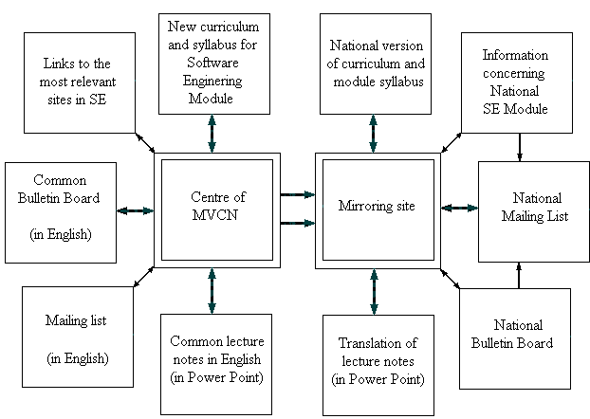
Figure 2. Structure of the Network and its mirroring sites

Special case with the mailing list can be expected at National Points that are centres themselves. Such situation can appear in Yugoslavia, but even more in Bulgaria that has got completely centralized educational system. In such case, national mailing list will be hosted at the University that is chosen to be a National Point. University lists as well as the boards containing information about the module at some particular university will be hosted at the school that is currently performing the module. Nevertheless, such freedom won’t interfere the main idea of the project: establishing of a framework for a joint module in line with European standards. MVCN for Software Engineering module initiated by the project “Reverse Engineering and distributed cooperative software development“ is the first international Virtual Classroom set in South-East Europe. Its ambition is also to become a pattern for MVCN for all joint modules within involved schools. Furthermore, it will also be a good basic for establishing European Credit Transfer System in South-East Europe.

